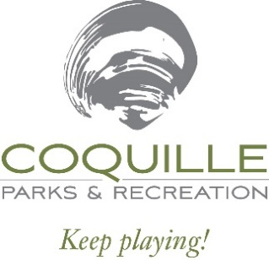

Payment Policy

Checkout & Payment:
- Registrations within RecDesk are NOT complete until you go through the Checkout process. If there are pending registrations in your cart, go to your Shopping Cart and click Checkout.
- You will be directed to the Waiver page where you must click Accept to continue.
- Fill out credit card information and click Continue. You will then be presented with a summary of the transaction (including a 3% processing fee). Click OK to complete the transaction or Cancel to go back.
- If you clicked OK, your credit card will be processed, and the registration process will be complete.

Privacy Policy:
We cannot view your full card number within our system, and we do not share this information with others. More information regarding RecDesk’s Privacy Policy may be found under the About Us > Forms tab on our main website.

For more information regarding registration payment, Recreation District #14, also doing business as Coquille Parks & Recreation may be reached via the following contacts:
Physical & Mailing Address: 13505 Highway 1085, Covington, Louisiana 70433, United States
Phone: (985) 892-9829
Email: info@coquillerecreation.com

In addition to Cash & Check, accepted forms of payment include:


